4. Birds
4.1 Land birds
Monthly land bird point counts are conducted along 7 transects around the atoll. Strong correlations between the annual number of sightings per species were found between 2002, 2003 and 2004 (r = 9.9, 9.8, 9.9). A significant increase in land bird sightings in 2004 was calculated (F2,36 = 3.26, P< 0.05) with the only exception being the Madagascar coucal. Sightings of the coucal during point counts have decreased over the years and even though the significance of this finding is questionable, further investigation may be necessary in the future.

Table 3.1: The number of land birds counted per annum

Species | 2002 | 2003 | 2004
Souimanga Sunbird | 1497 | 1679 | 2255
Madagascar Turtle Dove | 675 | 683 | 1016
Madagascar White-eye | 536 | 403 | 950
Madagascar Bulbul | 495 | 378 | 497
Comoro Blue Pigeon | 269 | 229 | 314
Aldabra Forest Fody | 108 | 200 | 243
Aldabra Drongo | 99 | 110 | 137
Aldabra Rail | 74 | 67 | 112
Madagascar Coucal | 44 | 38 | 13
Pied Crow | 45 | 13 | 35
Sacred Ibis | 34 | 24 | 32
Madagascar Kestrel | 17 | 13 | 24
Madagascar Nightjar | 2 | 1 | 2
Totals | 3895 | 3840 | 5630

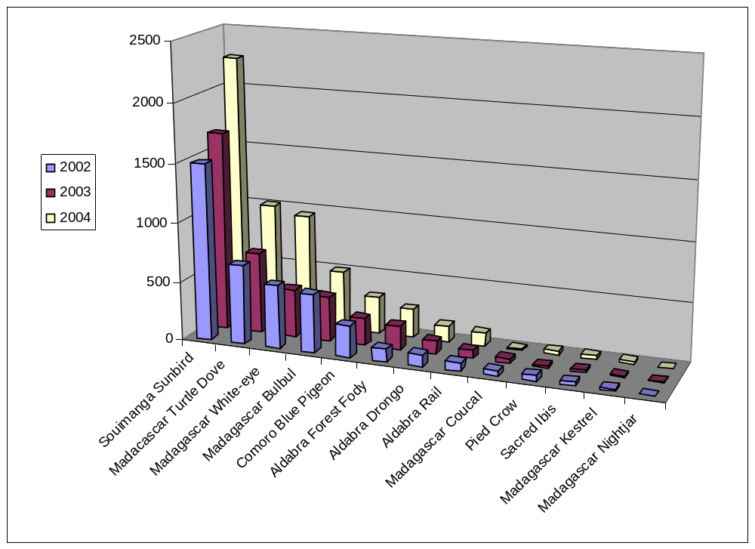
Figure 3.1: Total number of land birds counted per annum

4.2 Rail monitoring
Due to the high variance in previous datasets (see 2003 report), Mr Ross Wanless suggested that the rail transects are conducted quarterly rather than monthly. There was a suspicion that the birds were becoming accustomed to the voice recordings and becoming less responsive. From table 3.2, it is evident that there is still high variance in the data. The monitoring program is currently under review (see 2005 monthly reports)

Table 3.2: The number of rails counted per transect in 2004

Month | Malabar | Middle Camp | Polymnie | Gionnet
January | 24 | 27 | 3 | 8
May | 15 | 24 | 3 | 11
September | 9 | 12 | 3 | 6
December | 8 | 17 | 8 | 14

4.3 Wader counts
At the settlement, wader counts were conducted on a monthly basis (table 3.3). Counts were conducted on days where the low tide fell over the early morning. All birds present on the beach and exposed reef flat were counted between the settlement and the boat shelter at La Gigi. In places were the reef flat is very wide, many birds (especially the smaller less distinct ones) were not counted and as a result, these counts should not be treated as total counts. Additional variance created in the data is accounted to observer bias, variable weather conditions and the variable percentage of exposed reef flat during each count.

Table 3.3: Number of waders counted along the settlement transect in 2004

Species | Jan | Feb | Mar | Apr | May | Jun | Jul | Aug | Sep | Oct | Nov | Dec
Common sandpiper | 1
Eurasian curlew | 1
Whimbrel | 2 | 6 | 2 | 2 | 2 | 5 | 1 | 8 | 5 | 2 | 6 | 1
Ringed plover | 3 |  | 1
Sanderling | 3 | 4 | 6
Greater crested tern | 4 | 2 | 5 |  |  | 2 | 1 | 1 |  |  | 3 | 1
Lesser sandplover | 4 | 8 | 1 |  |  |  | 5 | 2 | 2 |  | 6 | 5
Grey heron | 5 | 4 | 4 | 7 | 11 | 8 | 4 | 6 | 5 | 8 | 8 | 4
Lesser crested tern | 6 |  | 7 |  |  |  |  |  |  | 1
Green-backed heron | 7 | 1 | 11 | 10 | 7 | 4 | 6 | 9 | 7 | 4 | 4 | 6
Greater sandplover | 8 | 10 |  | 1 | 2 |  |  |  |  | 8
Bar-tailed godwit | 9 | 6 |  |  |  |  | 1 |  |  |  | 10 | 1
Curlew sandpiper | 9 | 2 |  |  |  |  |  | 4
Grey plover | 12 | 7 | 6 | 1 |  |  | 4 | 2 | 3 | 2 | 8 | 4
Ruddy turnstone | 44 | 73 | 47 | 7 | 3 | 4 | 25 | 22 | 83 | 98 | 62 | 75
Crab plover | 78 | 50 | 37 |  | 20 | 7 | 35 | 15 | 3 |  | 72 | 35
Dimorphic egret | 102 | 152 | 104 | 16 | 81 | 27 | 11 | 40 | 27 | 3 | 60 | 11
Black-naped tern |  | 8 | 2 |  | 2 | 1 | 1 | 2 | 2 |  | 4 | 1
Caspian tern |  |  | 1 |  | 1 |  |  | 3
Greenshank |  |  |  |  |  |  |  | 2

Wader counts along the West Grande Terre were more difficult to organize. Counts were conducted during the monthly walk undertaken by rangers between the Dune Jean-Louis and Dune D’Messe camps. The walk is always conducted in the morning and on those days where the high tide fell over the early morning period, no counts were conducted.

Table 3.4: Number of waders counted between Dune Jean-Louis and Dune D’Messe in 2004

Species | Feb | Jun | Sep | Dec
Crab plover | 50 | 20 |  | 200
Grey plover | 2 |  | 5
Lesser sandplover | 60 |  |  | 44
Greater sandplover | 120 | 30 | 80 | 35
Whimbrel | 2 | 1 | 4 | 7
Curlew sandpiper | 6 |  | 90
Ruddy turnstone |  | 4 | 58 | 162
Sanderling |  |  | 2
Grey heron |  |  | 7 | 10
Green-backed heron |  | 2 | 4
Dimorphic egret |  | 1 | 4 | 2
Greater crested tern |  | 3 | 3
Caspian tern |  | 4 | 2 | 1
Bar tailed godwit | 4
Little tern |  |  |  | 50

4.4 Rare bird sightings
Opportunistic sightings of rare birds are presented in tables 3.5 – 3.16 below. It seems that sightings were recorded rather haphazardly.

Table 3.5: Opportunistic sightings of Little tern in 2004

Date | Recorders | Location | No. | Notes
19/08/2004 | TM/AD/MA | champignon des Os | 30-35 | resting on champignon/flying
24/09/2004 | TM | Cinq case | 20 | Bch # 38, resting
16/11/2004 | CB/AD | DDM | 7 | Feeding on the beach
18/02/2005 | AD/TM/TL/LJ | Settle beach #23 | 25 | Resting on sand bank

Table 3.6: Opportunistic sightings of Broad-billed roller in 2004

Date | Recorders | Location | No. | Notes
18/03/2004 | AD/US | Station Picard | 1 | resting in casuarina tree back-path area
15/11/2004 | US | Old settlement | 2 | resting in flame tree near the chapel
18/11/2004 | TM | Old Settlement | 1 | In Indian Almond tree, then being chased by drongos

Table 3.7: Opportunistic sightings of Brown booby in 2004

Date | Recorders | Location | No. | Notes
03/09/2004 | SY | West Channels | 1 | Adult sitting on champignon

Table 3.8: Opportunistic sightings of Curlew sandpiper in 2004

Date | Recorders | Location | No. | Notes
11/09/2004 | TM | settlement beach | 1 | feeding in seaweeds
Table 3.9: Opportunistic sightings of Greater Flamingo in 2004

Date | Recorders | Location | No. | Notes
25/02/2004 | US/NJ | Bassin Flamant | 9 | feeding/airborne on my arrival
23/03/2004 | AD/TM | Cinq case landing | 3 | feeding
24/03/2004 | TM/US | cc. south in pools | 3 | feeding 2 adult,1 juvenile
02/06/2004 | PR/AD | cc. coco pts 20 | 2 | flying over head
02/09/2004 | TM/AD | Bassin Flamant | 1 | feeding/ young bird seen
02/10/2004 | US,LA,CB | Cinq case landing | 3 | feeding
01/11/2004 | TM/AD/CH | Inland Pool C.Case | 21 | feeding, preening, 3 juveniles present.
15/12/2004 | AD/CB/SR/US | Inland Pool C.Case | 9 | feeding 1 juvenile present

Table 3.10: Opportunistic sightings of Caspian tern in 2004

Date | Recorders | Location | No. | Notes
11/03/2004 | US/LA | Ile esprit | 2 | Get airborne on arrival (nest + 2 eggs)
19/03/2004 | TM/US/AD | WGT | 2 | resting on sand Bch # 3
27/05/2004 | US/LA/AD | grand poche | 4 | resting on beach
17/06/2004 | AD | Bch 47 Zone 3 | 1 | resting on sand bank
24/06/2004 | AD/LA/SY | Anse Owen | 7 | resting on beach + 1egg on nest
02/07/2004 | AD/TM/CB | grand poche | 9 | 1egg on beach + 1 chick Flying
06/07/2004 | AD | DDM around hut | 2 | flying
07/07/2004 | AD/TM | DDM landing stage | 3 | 1chick + 2 adult flying
08/07/2004 | AD/TM/CBLA | grand poche | 9 | flying + 1 chick
20/07/2004 | AD | WGT Bch # 6 | 2 | 1 adult + 1 chick flying
20/07/2004 | AD/TM | WGT Bch # 15 | 1 | adult flying
29/07/2004 | AD/LA/CB/PR | Ile Moustique | 9 | flying
25/10/2004 | CB | settlement beach | 3 | adult flying
16/11/2004 | CB/AD | Dune De Messe | 1 | flying

Table 3.11: Opportunistic sightings of Greater sandplover in 2004

Date | Recorders | Location | No. | Notes
03/09/2004 | US | beach # 25 | 50 | resting on the dune
28/09/2004 | US,LA | beach # 25 | 50 | resting / airborne on our arrival.
29/09/2004 | TM/CB | DJL Coast | 80 | feeding
25/10/2004 | CB | settlement beach | 4 | feeding
26/10/2004 | CB/US | settlement beach | 9 | feeding
09/11/2004 | AD/US | settlement beach | 2 | feeding
25/01/2005 | AD/US | settlement beach | 1 | feeding
07/02/2004 | AD | settlement beach | 3 | feeding at low tide
10/02/2005 | US | settlement beach | 4 | resting on sand bank

Table 3.12: Opportunistic sightings of Lesser sandplover in 2004

Date | Recorders | Location | No. | Notes
03/09/2004 | US | # 25 | 30 | resting on dunes
13/10/2004 | AD/TM | settlement beach | 8 | feeding
25/10/2004 | CB | settlement beach | 9 | feeding
26/10/2004 | CB/US | settlement beach | 8 | feeding
27/11/2004 | CB | settlement beach | 7 | feeding
28/12/2004 | CB | settlement beach | 3 | feeding

Table 3.13: Opportunistic sightings of Greenshank in 2004

Date | Recorders | Location | No. | Notes
13/10/2004 | TM/AD | settlement beach | 2 | feeding along the coast
25/10/2004 | CB | settlement beach | 7 | feeding
26/10/2004 | CB/US | settlement beach | 1 | feeding along the coast
09/11/2004 | AD/US | settlement beach | 1 | fending along the coast
14/12/2004 | AD/TL | C.C coco pts # 20 | 1 | feeding inland pool CC coco

Table 3.14: Opportunistic sightings of Eurasian golden oriole in 2004

Date | Recorders | Location | No. | Notes
12/03/2004 | US/TM/AD | Anse Mais | 3 | Roosting in casuarina trees
14/03/2004 | US/LA/AD | Settlement | 1 | Roosting in casuarina trees

Table 3.15: Opportunistic sightings of Tree pipit in 2004

Date | Recorders | Location | No. | Notes
13/03/2004 | US | Old Settlement | 1 | Feeding in tree ( Permina ceratifolia)

Table 3.16: Opportunistic sightings of Sanderlings in 2004

Date | Recorders | Location | No. | Notes
07/06/2004 | AD | settlement beach | 1 | Feeding ashore
13/10/2004 | AD/TM | settlement beach | 10 | Feeding
25/10/2004 | CB | settlement beach | 18 | Feeding
26/10/2004 | CB/US | settlement beach | 9 | Feeding among seaweeds.
09/11/2004 | US/AD | settlement beach | 2 | Feeding
27/11/2004 | CB | settlement beach | 10 | Feeding
28/12/2004 | CB | settlement beach | 30 | Feeding

